**Lab 6 Home Assignment Submission**

*Yash Srivastava*  
*220962368*  
*28/02/2025 (****Lab 6 Home Assignment****)*

**1. Basic Arithmetic Calculator Web App in Django**

**2. Dynamic Magazine Cover Generator with Customization in Django**

**3. Book Information Web App with Navigation in Django**

**Project Structure:**

week6/ # Main Django project directory

│── arithmetic_app/ # App for arithmetic operations

│── magazine_app/ # App for magazine cover generation

│── bookinfo_app/ # App for book information display

│── week6/ # Main project settings

│── templates/ # Shared templates directory

│── static/ # Shared static files (CSS, JS)

│── manage.py # Django management script

**week6/settings.py:**

INSTALLED_APPS = [

…

'arithmetic_app',

'magazine_app',

'bookinfo_app',

]

**week6/urls.py:**

from django.contrib import admin

from django.urls import path, include

urlpatterns = [

path('admin/', admin.site.urls),

path('arithmetic/', include('arithmetic_app.urls')),

path('magazine/', include('magazine_app.urls')),

path('bookinfo/', include('bookinfo_app.urls')),

]

**Arithmetic Operations App (arithmetic_app)**

**arithmetic_app/views.py:**

from django.shortcuts import render

def arithmetic_home(request):

result = None

if request.method == "POST":

num1 = int(request.POST.get('num1', 0))

num2 = int(request.POST.get('num2', 0))

operation = request.POST.get('operation')

if operation == "add":

result = num1 + num2

elif operation == "subtract":

result = num1 - num2

elif operation == "multiply":

result = num1 * num2

elif operation == "divide":

result = num1 / num2 if num2 != 0 else "Undefined"

return render(request, 'arithmetic.html', {"result": result})

**arithmetic_app/urls.py:**

from django.urls import path

from .views import arithmetic_home

urlpatterns = [

path('', arithmetic_home, name='arithmetic_home'),

]

**arithmetic_app/templates/arithmetic.html:**

<h2>Basic Arithmetic Operations</h2>

<form method="post">

{% csrf_token %}

<label>Enter Number 1:</label>

<input type="number" name="num1" required>

<label>Select Operator:</label>

<select name="operation">

<option value="add">+</option>

<option value="subtract">-</option>

<option value="multiply">*</option>

<option value="divide">/</option>

</select>

<label>Enter Number 2:</label>

<input type="number" name="num2" required>

<button type="submit">Calculate</button>

</form>

{% if result is not None %}

<p>Result: {{ result }}</p>

{% endif %}

**Magazine Cover Generator (magazine_app)**

**magazine_app/views.py:**

from django.shortcuts import render

def magazine_cover(request):

context = {

'message': 'Magazine Cover',

'color': '#000000',

'fontsize': '24px',

'fontcolor': '#ffffff',

'bg_image': None,

}

if request.method == "POST":

context['message'] = request.POST.get('message', 'Magazine Cover')

context['color'] = request.POST.get('color', '#000000')

context['fontsize'] = request.POST.get('fontsize', '24px')

context['fontcolor'] = request.POST.get('fontcolor', '#ffffff')

context['bg_image'] = request.POST.get('bg_image', '')

return render(request, 'magazine.html', context)

**magazine_app/urls.py:**

from django.urls import path

from .views import magazine_cover

urlpatterns = [

path('', magazine_cover, name='magazine_cover'),

]

**magazine_app/templates/magazine.html:**

<!DOCTYPE html>

<html lang="en">

<head>

<link rel="stylesheet" type="text/css" href="/static/style.css">

</head>

<body>

<h2>Magazine Cover Generator</h2>

<form method="post">

{% csrf_token %}

<label>Title:</label>

<input type="text" name="message" placeholder="Enter title" required>

<label>Background Color:</label>

<input type="color" name="color">

<label>Font Size (px):</label>

<input type="number" name="fontsize" placeholder="Font size" required>

<label>Font Color:</label>

<input type="color" name="fontcolor">

<label>Background Image URL:</label>

<input type="text" name="bg_image" placeholder="Enter image URL">

<button type="submit">Generate Cover</button>

</form>

<div class="magazine-cover" style="background-color: {{ color }}; font-size: {{ fontsize }}px; color: {{ fontcolor }};

background-image: url('{{ bg_image }}'); background-size: cover; width: 100%; height: 300px; text-align: center; padding: 50px;">

<h1>{{ message }}</h1>

</div>

</body>

</html>

**static/style.css:**

.magazine-cover {

border: 5px solid black;

display: flex;

align-items: center;

justify-content: center;

}

**Book Info App (bookinfo_app)**

**bookinfo_app/views.py:**

from django.shortcuts import render

def book_home(request):

return render(request, 'book_home.html')

def book_metadata(request):

return render(request, 'book_metadata.html')

def book_reviews(request):

return render(request, 'book_reviews.html')

def book_publisher(request):

return render(request, 'book_publisher.html')

**bookinfo_app/urls.py:**

from django.urls import path

from .views import book_home, book_metadata, book_reviews, book_publisher

urlpatterns = [

path('', book_home, name='book_home'),

path('metadata/', book_metadata, name='book_metadata'),

path('reviews/', book_reviews, name='book_reviews'),

path('publisher/', book_publisher, name='book_publisher'),

]

**bookinfo_app/templates/book_home.html:**

<h1>Book Information</h1>

<img src="/static/book_cover.jpg" width="200">

<ul>

<li><a href="{% url 'book_metadata' %}">Metadata</a></li>

<li><a href="{% url 'book_reviews' %}">Reviews</a></li>

<li><a href="{% url 'book_publisher' %}">Publisher Info</a></li>

</ul>

**bookinfo_app/templates/book_metadata.html:**

<a href="{% url 'book_home' %}">Back to Home</a>

<h2>Book Metadata</h2>

<p>Author: John Doe</p>

<p>Published: 2024</p>

<p>ISBN: 123-456-789</p>

**bookinfo_app/templates/book_reviews.html:**

<a href="{% url 'book_home' %}">Back to Home</a>

<h2>Book Reviews</h2>

<p>"An amazing read!" - Reader 1</p>

<p>"5 stars!" - Reader 2</p>

**bookinfo_app/templates/book_publisher.html:**

<a href="{% url 'book_home' %}">Back to Home</a>

<h2>Publisher Information</h2>

<p>Published by: XYZ Publishers</p>

<p>Contact: [xyz@publisher.com</p](mailto:xyz@publisher.com%3c/p)>

**Screenshot of Arithmetic app at** [**http://127.0.0.1:8000/arithmetic/**](http://127.0.0.1:8000/arithmetic/)

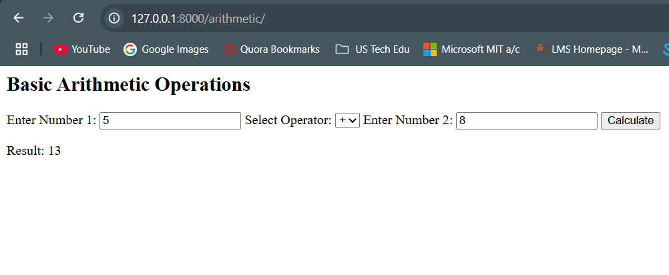

**Screenshot of Magazine Cover app at** [**http://127.0.0.1:8000/magazine/**](http://127.0.0.1:8000/magazine/)

**Screenshot of Book Info app at** [**http://127.0.0.1:8000/bookinfo/**](http://127.0.0.1:8000/bookinfo/)

